FABRICATION MANUAL （Update 2）
1. File preparation
A dxf file named “DF_XXX.dxf” (XXX stands for the ID of the board) should be provided for each board. The content is illustrated here:
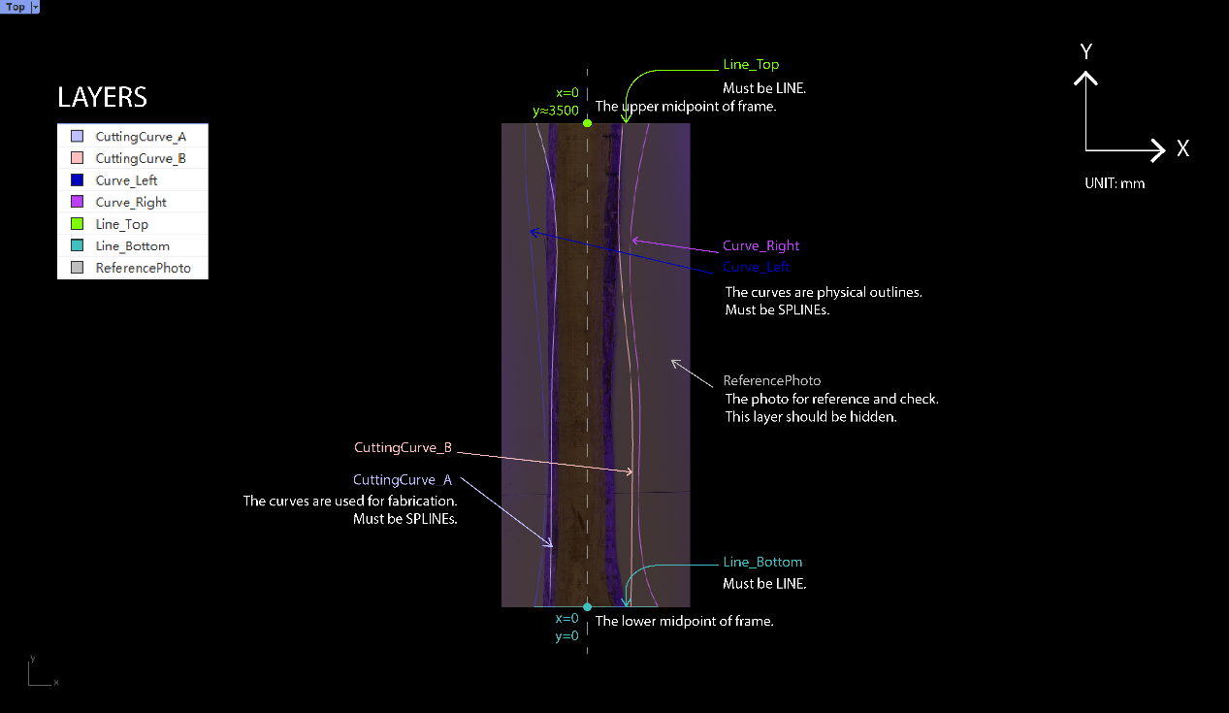
The exact content example without any illustration is shown here:
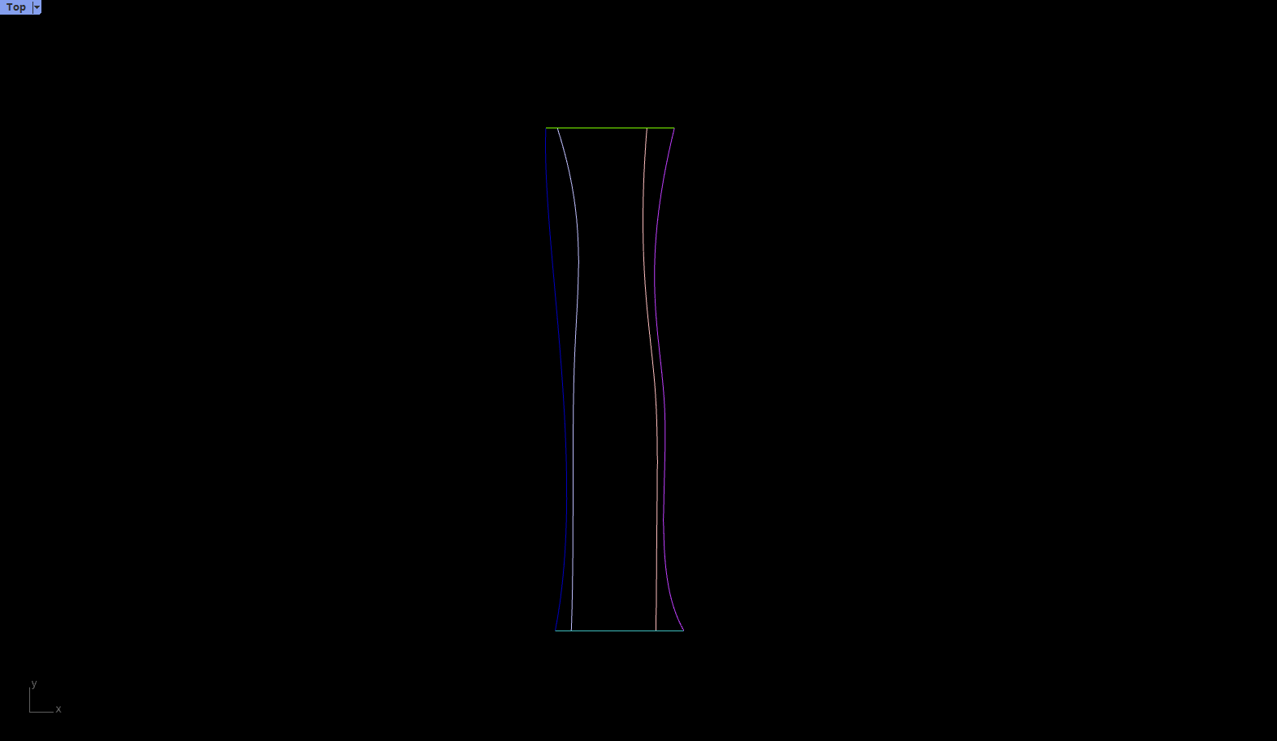
The example dxf file is attached.
2. Board preparation
Each board should be marked two section middle points, an arrow, and an ID before sent for fabrication. The arrow points to the origin point. The ID should be compatible with the digital file name.
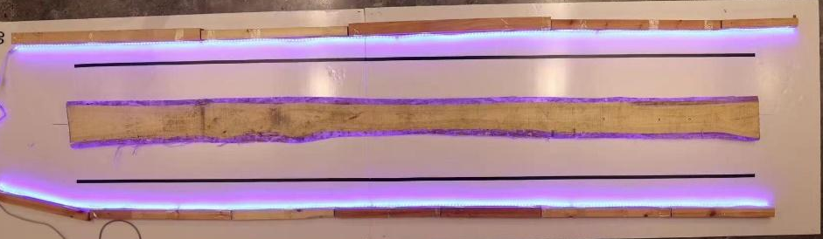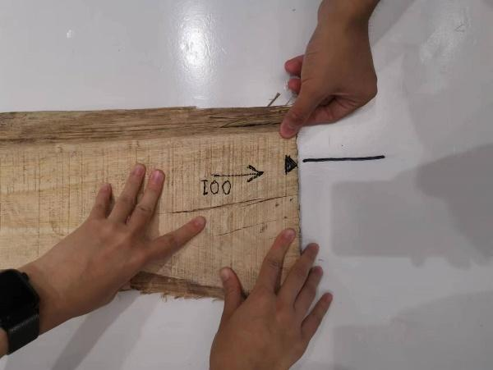
Arrow pointing to the origin and ID
Triangle marker on the edge
3. Board positioning
The coordinate system is drawn on the fabrication table illustrated in yellow. The origin point or the board should be overlapped to the origin point on the fabrication table. Then the other middle point should lie on the axis drawn in the longitudinal direction.


4. Board fixing
Self-tapping screws are used to fix the boards. Each board needs three screws. Two of them are close to the markers at the end, and the last screw should be approximately at the middle.
NOTE:
- Press the board when screwing.
- Make sure the miller won’t touch the screw.
5. Start milling
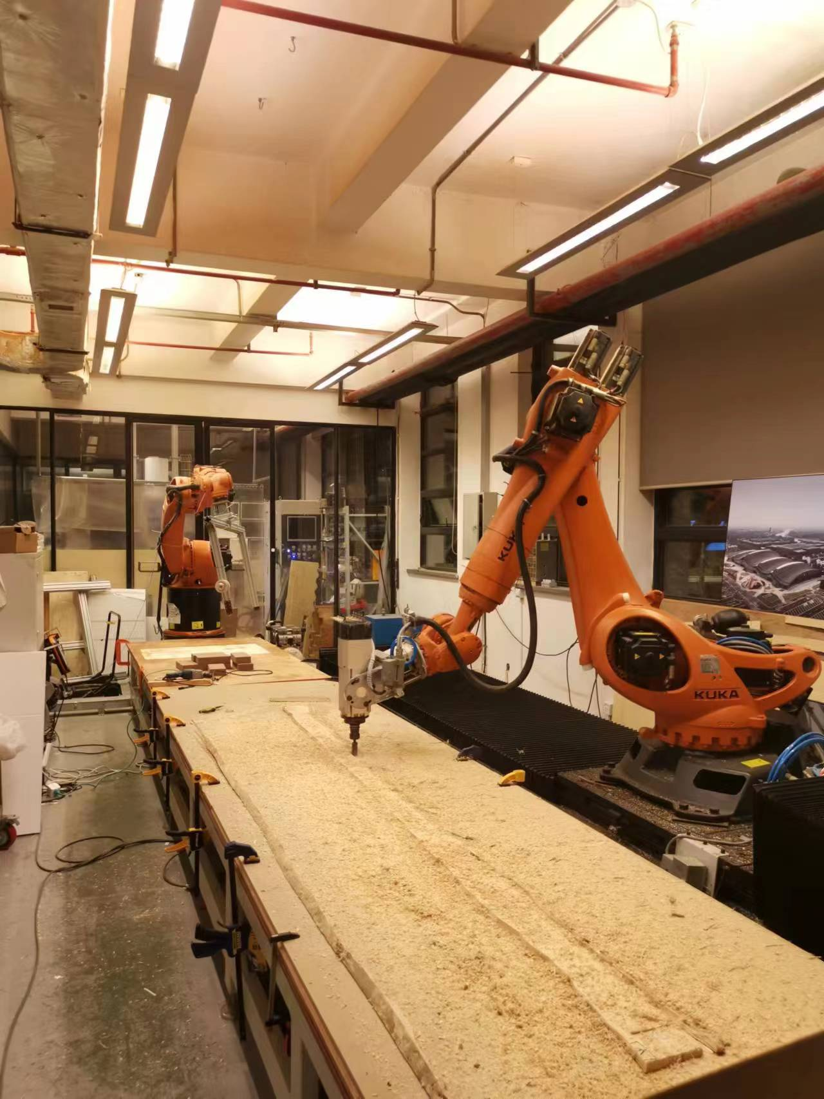
The fabrication team will do the milling. The steps are listed below as a reminder.
- Switch on the power of the miller and the fan simultaneously.
- Save necessary files in a USB and plug in to the controller.
- Switch to expert user group (pwd: kuka)
- Copy src file to KUKA.
- Press the file, click “select”
- Check E1=3594.03, E2=720 in the src file.
- Turn on the milling motor: Menu - Display - Inputs/outputs - Digital I/O - Output - 16 - Value (hold down left safety button) - close
- If the miller is not heated up, let the fan run for two minutes.
- Switch to automatic mode.
- Set a proper speed, and press the start button.
6. Board removal
Steps to remove the board:
- Turn off the drilling motor.
- Take out the screws.
- Remove the board.
- Clean the table.

